(Image for homepage)

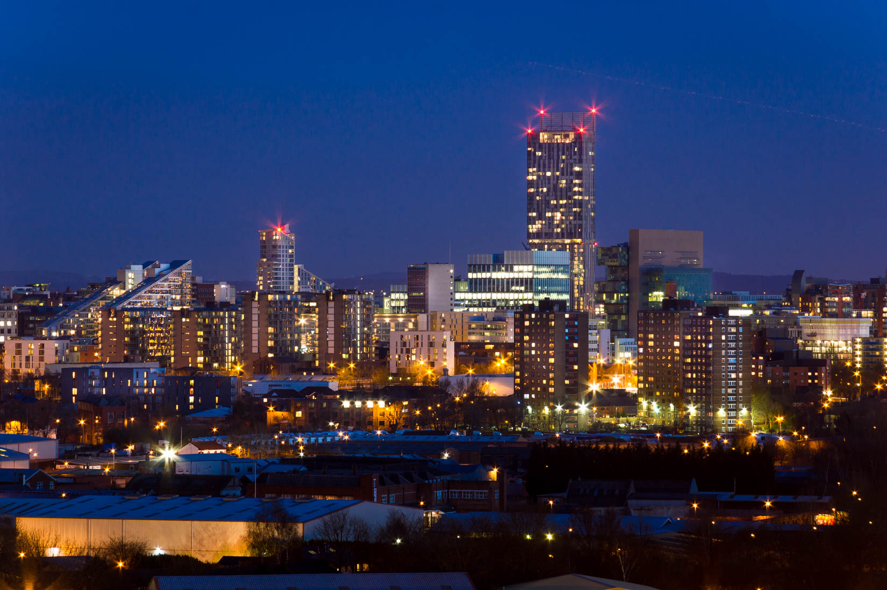

(Image for Event/Place Page)



(Image for Contact Us Page)

